inTitle: | Cloud Infrastructure Practice
Updated: | April 3, 2025 | Due Date: | Midnight before the next class meeting.
Purpose: | The purpose of this lab is to provide hands-on experience with essential AWS cloud services, including EC2, S3, IAM, and Security Groups, enabling you to understand and apply fundamental concepts of cloud infrastructure management and security.
Knowledge: | After completing this lab, you will have practical knowledge of launching and managing EC2 instances, configuring S3 buckets, creating IAM policies, and securing cloud environments using AWS tools.
Task/Activity: | A. EC2 (Elastic Cloud Compute)  B. S3 (Simple Storage Service)  C. IAM (Identity and Access Management)  D. Security Groups
Criteria for Success: | Success in this lab is marked by accurate task completion, effective analysis, documentation, and clear communication of findings. A crucial aspect involves reflecting on the purpose of the lab, linking procedures to broader concepts, and recognizing the lab's significance within the course.  Overall, success is not only measured by technical proficiency but also by critical thinking, effective communication, and a reflective summary that captures the challenges faced and insights gained throughout the lab experience.
- EC2 (Elastic Cloud Compute)
Using what we learned in the previous lab, along with some additional research using the AWS Documentation (https://docs.aws.amazon.com/), complete the following tasks.

Launch and Connect to an EC2 Instance:
- Launch an EC2 instance using Amazon Linux 2 and t2.micro.
- Create and download a key pair for SSH access.
- Connect to the instance via SSH using the terminal or PuTTY.
- Run basic Linux commands (uname -a, df -h) to verify connection.
Attach Screenshot here 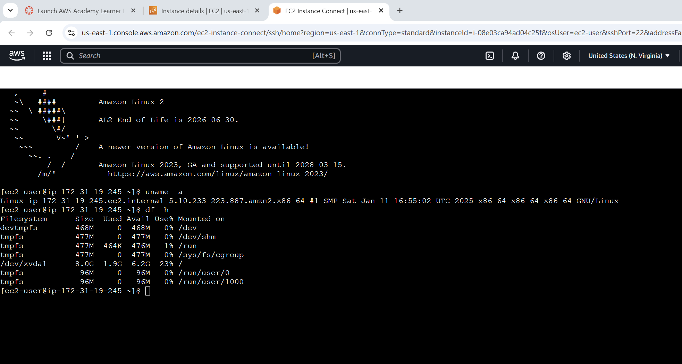

Install and Run a Web Server
- Use your EC2 instance created in the last step.
- Install Apache HTTP server using sudo yum install httpd.
- Start the service with sudo service httpd start.
Attach Screenshot here 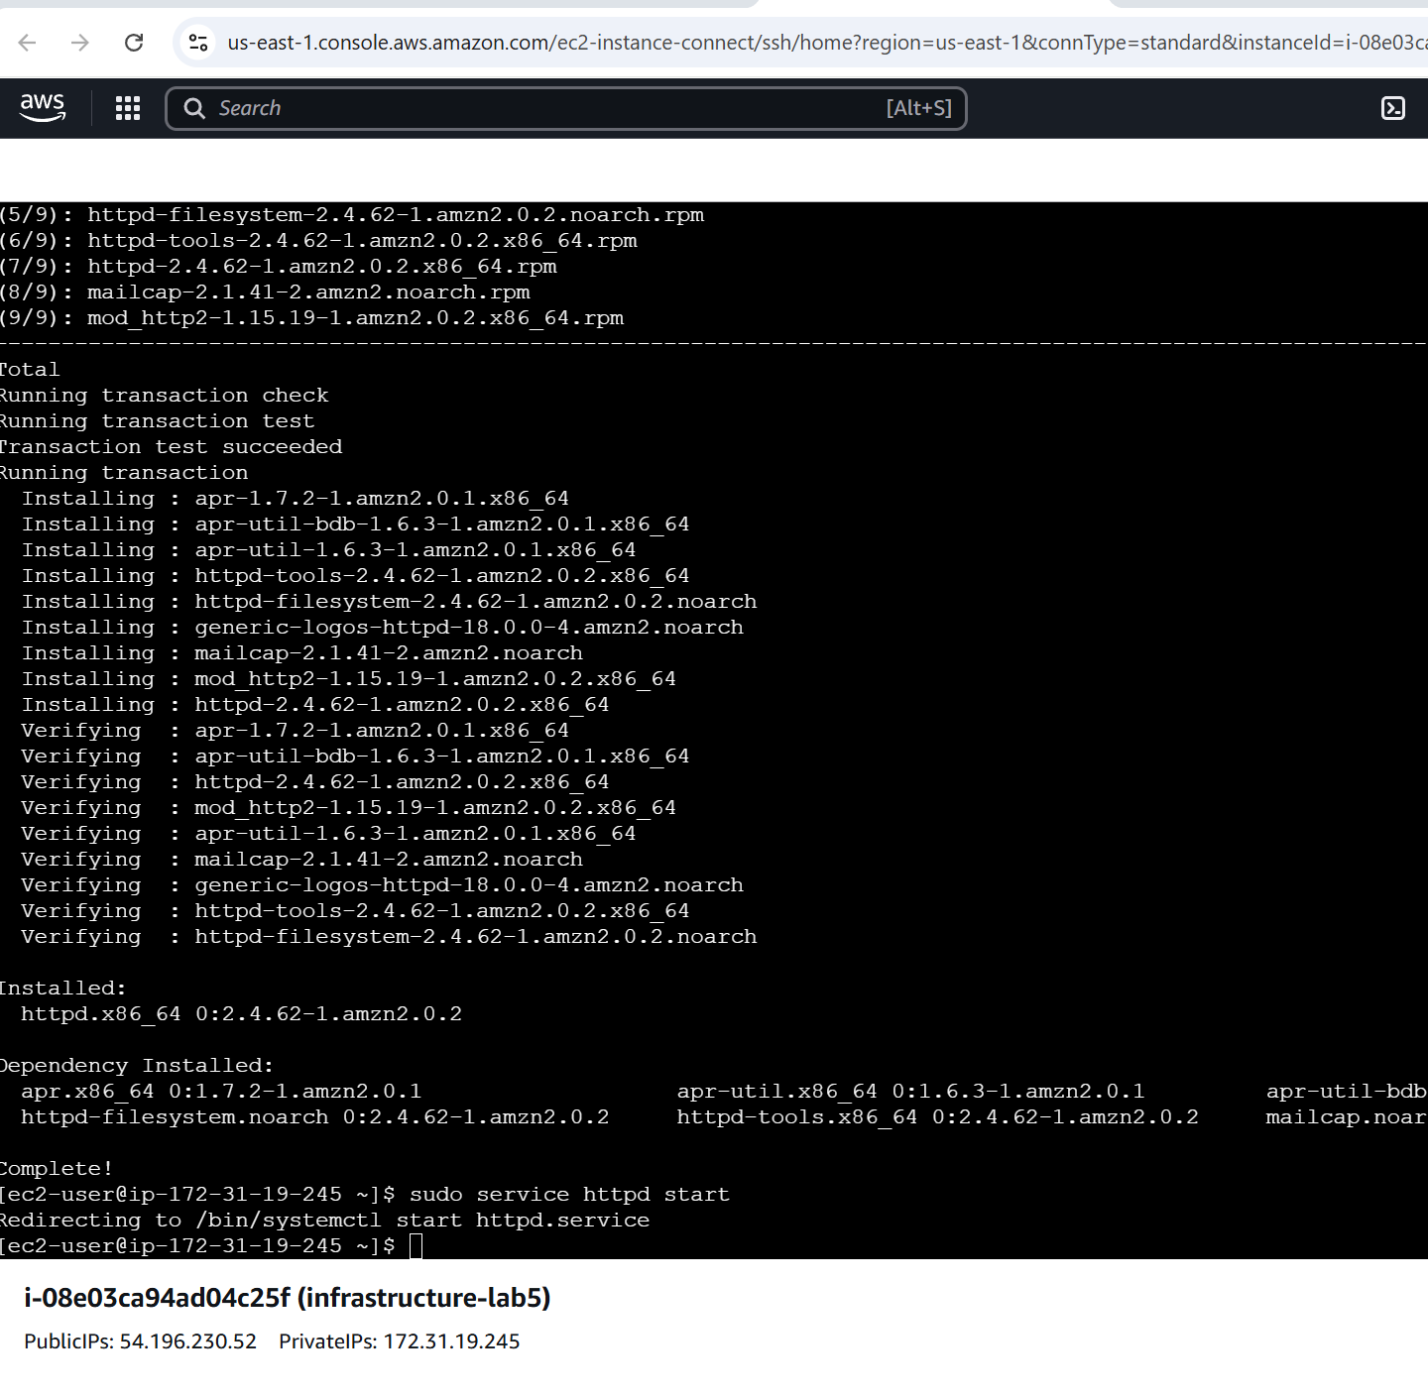
- Access the instance’s public IP in a browser to view the default web page.
Attach Screenshot here 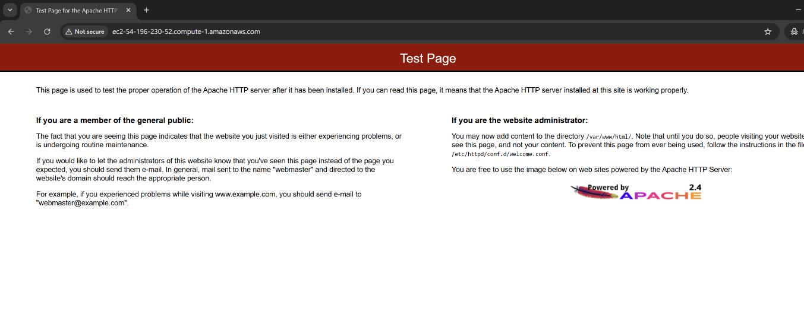

Create a Custom HTML Page
- Navigate to the /var/www/html folder.
- Delete the existing index.html file.
- Create a new, simple HTML file (index.html) with custom content. (Use vi in the terminal to create and edit this file.)
- Access the new page through the instance’s public IP in the browser.
Attach Screenshot here

Monitor EC2 Performance with CloudWatch
- Navigate to CloudWatch (use search at the top) and monitor the CPU utilization of the instance you created earlier. (Hint: You will need to look at the AWS documentation to do this – a good skill to find, read, and utilize documentation resources.)
- Set up an alarm to trigger when CPU usage exceeds 70%.
Attach Screenshot here 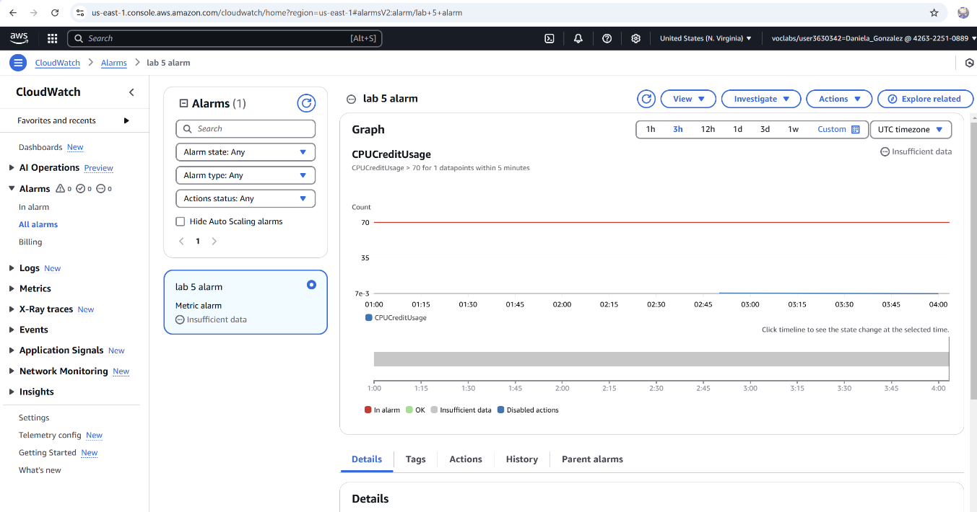

- Perform activities on the instance to generate load and trigger the alarm.
Here is a good way to do this:
# sudo amazon-linux-extras enable epel ß This will enable some extra repositories
# sudo yum install -y epel-release ß This will install those repositories
# sudo yum install -y stress ß This will install the stress tool to force the processor to run
# sudo stress --cpu 1 --timeout 120 ß This will run a stress test on the server for 120 seconds
- Navigate to the alarm in CloudWatch and provide a screenshot.
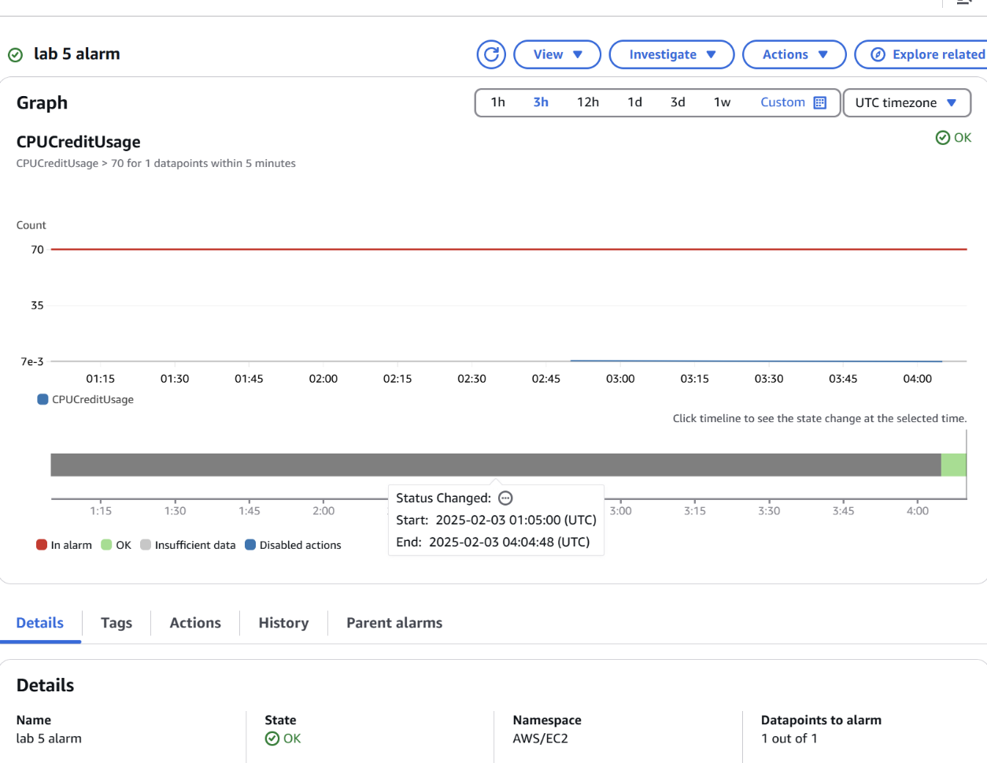
- S3 (Simple Storage Service)

Create an S3 Bucket and Upload Files
- Navigate to the S3 dashboard and create a new bucket with a unique name.
- Upload a text file to the bucket.
- Retrieve the file’s URL and attempt to access it (the file should not be publicly accessible yet).
Attach Screenshot here 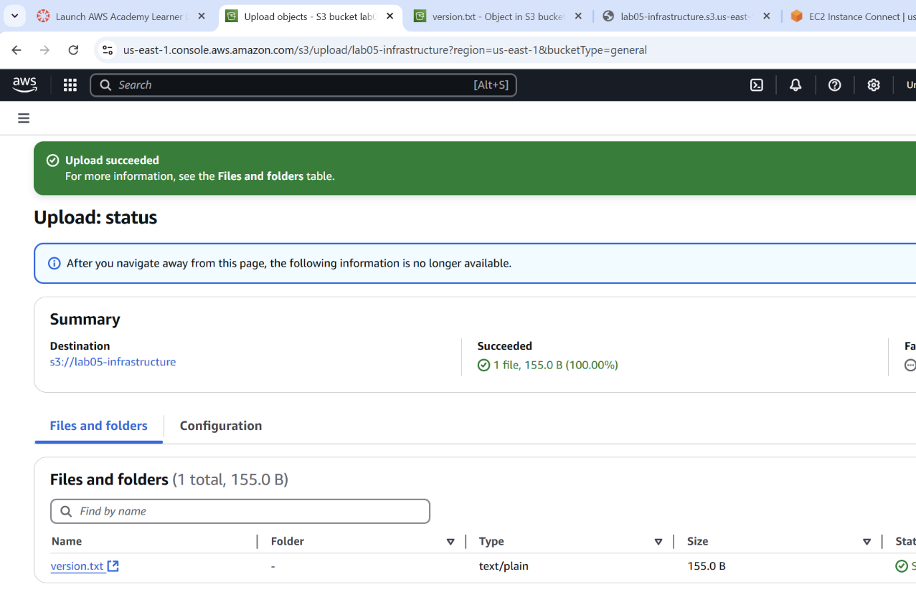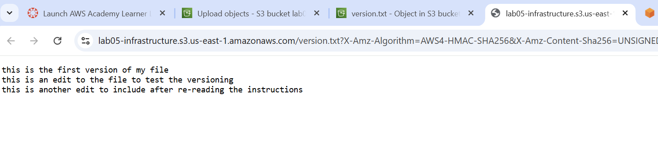

Enable Public Access to an S3 File
- Select the uploaded file from above.
- Modify the permissions to allow public access.
- Retrieve the new URL and verify that the file is publicly accessible.
Attach Screenshot here 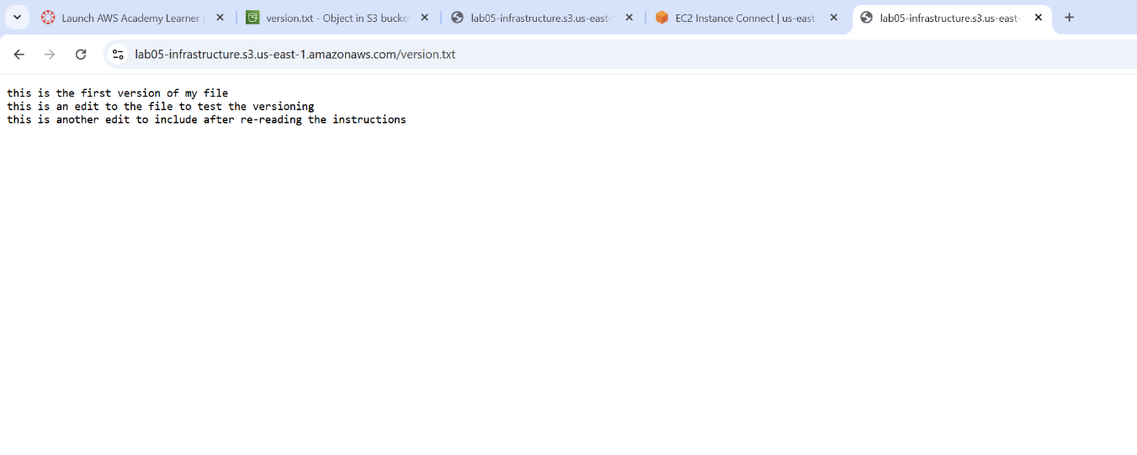

Enable Versioning for an S3 Bucket
- Enable versioning on your S3 bucket.
- Upload an updated version of an existing file.
- List and view different versions of the same file in the bucket.
Attach Screenshot here 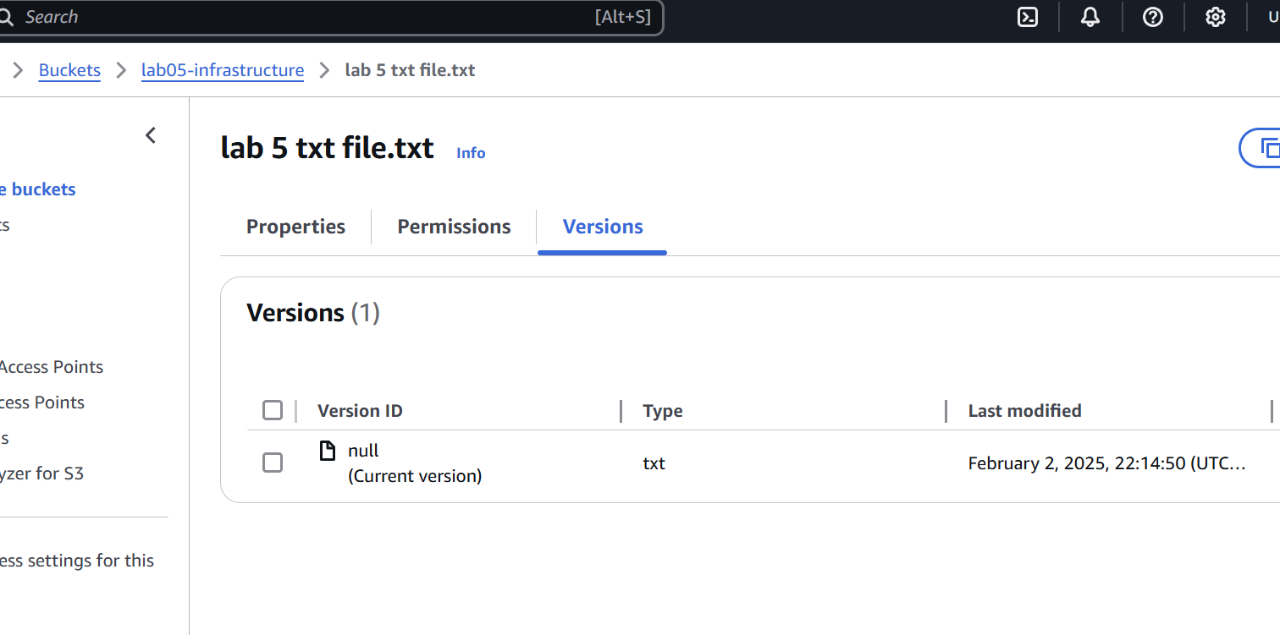

Configure Bucket Lifecycle Policies
- Create a new S3 bucket or use an existing one.
- Configure a lifecycle rule to transition files older than 30 days to Glacier storage.
Attach Screenshot here
- Optionally, set a rule to delete files older than 90 days.
Attach Screenshot here

Hosting a Static Website with S3
- Create a new S3 bucket.
- Upload an HTML file as your website’s home page (name it index.html).
- Enable static website hosting in the bucket’s settings.
- Access the website via the provided S3 endpoint.
Attach Screenshot here
- Security Groups

Create a New Security Group
- Create a new security group allowing SSH (port 22) and HTTP (port 80).
Attach Screenshot here
- Launch an EC2 instance and associate it with the new security group.
- Verify access via SSH and HTTP.
Attach Screenshot here

Restrict Access by IP Address
- Modify the security group to allow SSH access only from your IP address.
Attach Screenshot here
- Attempt to access the EC2 instance from your IP and a different IP (e.g., a VPN).
Attach Screenshot here
- Verify that only your IP has access.

Configure Inbound and Outbound Rules
- Launch an EC2 instance with a default security group.
- Modify the inbound rules to allow HTTP and HTTPS traffic.
Attach Screenshot here
- Modify the outbound rules to allow access only to a specific IP or port.
Attach Screenshot here

Dynamic Security Group Management
- Launch an EC2 instance with a security group allowing only SSH.
- Temporarily add rules to allow HTTP traffic for testing.
Attach Screenshot here
- Remove the HTTP rule when testing is complete.
Attach Screenshot here

Audit and Review Security Group Rules
- Review the security groups associated with your EC2 instances.
Attach Screenshot here
- Identify any rules that allow unnecessary or insecure access (e.g., open ports).
- Modify or remove rules to improve security.
Attach Screenshot here
- Reflection
Reflect on your experience with configuring and managing cloud services in this lab. Consider how tasks like launching EC2 instances, setting up security groups, and using S3 for storage contribute to real-world cloud infrastructure management. What challenges did you face, and how did you overcome them? Discuss how these tasks help you understand broader concepts of cloud computing and security.
I want to say that this lab really showcased my inadequacies on this topic. I am ashamed to admit that I do not know what I am doing in this lab. I want to apologize for the incomplete assignment, but I do not know what I am doing.

